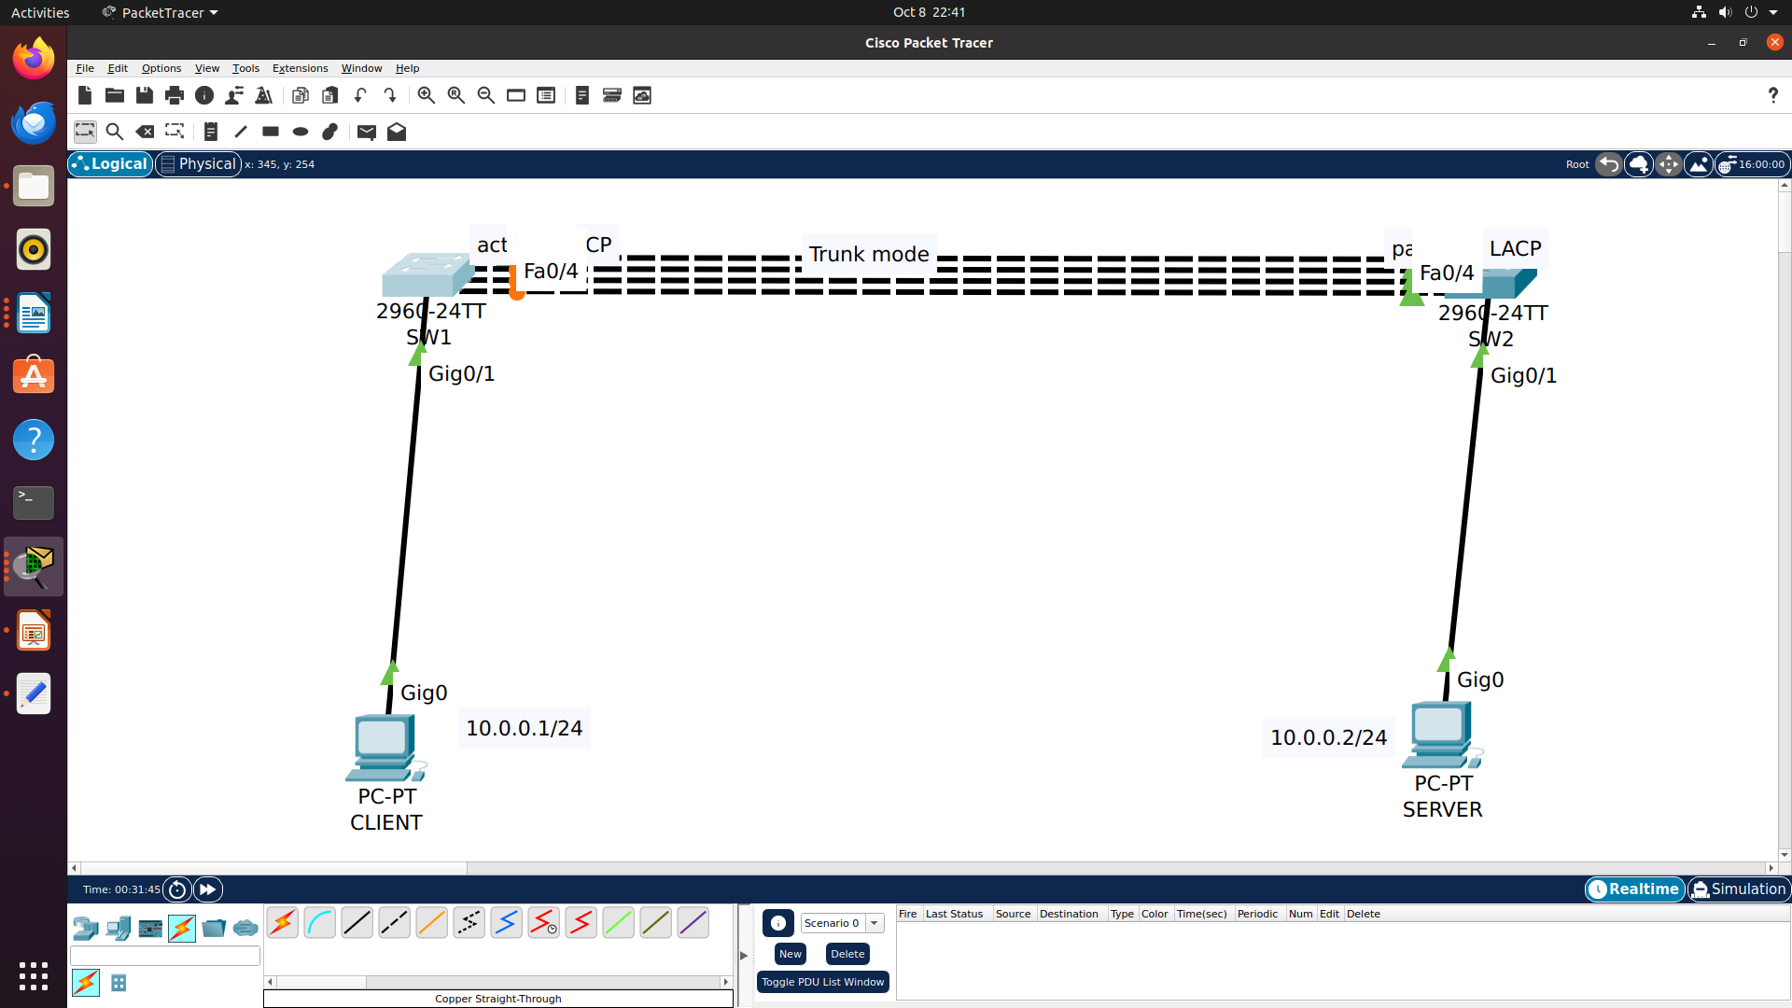

Etherchannel (LACP)

SW1(config)#interface range fastEthernet 0/1-4
SW1(config-if-range)#switchport mode trunk

SW1(config-if-range)#channel-group 1 mode active

SW2(config)#interface range fastEthernet 0/1-4
SW2(config-if-range)#switchport mode trunk

SW2(config-if-range)#channel-group 1 mode passive

SW1#sh etherchannel summary

SW2#show interfaces port-channel 1
Port-channel1 is up, line protocol is up (connected)
Hardware is EtherChannel, address is 0002.17dd.1ce3 (bia 0002.17dd.1ce3)
MTU 1500 bytes, BW 400000 Kbit, DLY 1000 usec,
reliability 255/255, txload 1/255, rxload 1/255
Encapsulation ARPA, loopback not set
Keepalive set (10 sec)
Half-duplex, 400Mb/s
input flow-control is off, output flow-control is off
Members in this channel: Fa0/1 ,Fa0/2 ,Fa0/3 ,Fa0/4 ,
ARP type: ARPA, ARP Timeout 04:00:00
Last input 00:00:08, output 00:00:05, output hang never
Last clearing of "show interface" counters never
Input queue: 0/75/0/0 (size/max/drops/flushes); Total output drops: 0
Queueing strategy: fifo
Output queue :0/40 (size/max)
5 minute input rate 0 bits/sec, 0 packets/sec
5 minute output rate 0 bits/sec, 0 packets/sec
956 packets input, 193351 bytes, 0 no buffer
Received 956 broadcasts, 0 runts, 0 giants, 0 throttles
0 input errors, 0 CRC, 0 frame, 0 overrun, 0 ignored, 0 abort
0 watchdog, 0 multicast, 0 pause input
0 input packets with dribble condition detected
2357 packets output, 263570 bytes, 0 underruns
0 output errors, 0 collisions, 10 interface resets
0 babbles, 0 late collision, 0 deferred
0 lost carrier, 0 no carrier
0 output buffer failures, 0 output buffers swapped out

